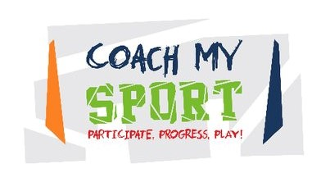

Please complete your details below. You will receive an email confirming your booking.
Please note: booking form and a 50% deposit are required before your party can be confirmed.
For more information contact Tony on 07590 900101 or email: admin@coachmysport.co.uk

*Required

Child’s Name and Surname *
If more than 1 child, please include all names
_______________________________ _______________________________

Child’s Date of Birth *
_______________________________ _______________________________

Parent’s Name and Surname * Home Address and Postcode *
________________________________ _________________________________
_________________________________
_________________________________

Telephone - Home * Telephone - Mobile *
________________________________ __________________________________

Email Address *
________________________________

Date and Time of Party *
_________________________________

Cost: £100 (UP TO 12 CHILDREN) OR £120 (MORE THAN 12 CHILDREN)

Party Venue * Party Venue Postcode *
__________________________________ ___________________________

Anticipated number of Children Attending *
Final numbers need to be confirmed two days prior to the party.

_____________________________________________

How will you be paying? *
BACS: Account number: 16551968 Sort Code: 80-22-60
Please use your child’s name and surname as reference.
Cheque: Payable to Coach My Sport and sent to Unit 83 STEP, Stirling Enterprise Park, Stirling, FK7
7RP

Please read the terms and conditions *
Our cost does not include the cost of hall hire, party food or drinks.
Deposit is required and full payment needed to be paid before party.
No bookings can be confirmed until a booking form has been received.
Payment details as above. A full refund will be given if written cancellation is received within two
weeks prior to the party date, if not we are unable to provide a refund.
There is no minimum number of children, but the maximum number is 24 (2 coaches) and this would
be dependent on the size of the hall.
Party duration includes time for party food, drinks, and cake.
Although we run all the classes in a safe and secure environment Coach My Sport (CiC) cannot be
responsible for any accidents.
The host parents need to make sure that they have spoken to all parents about taking photographs
and videos plus have contact details of parents in case of emergencies.
Please let parents know it’s a sports themed party so the children need to come dressed
appropriately.

I agree to the terms and conditions: Yes/No * delete as appropriate

Signed: _______________________ Date: ______________________

