PARTY BOOKING FORM
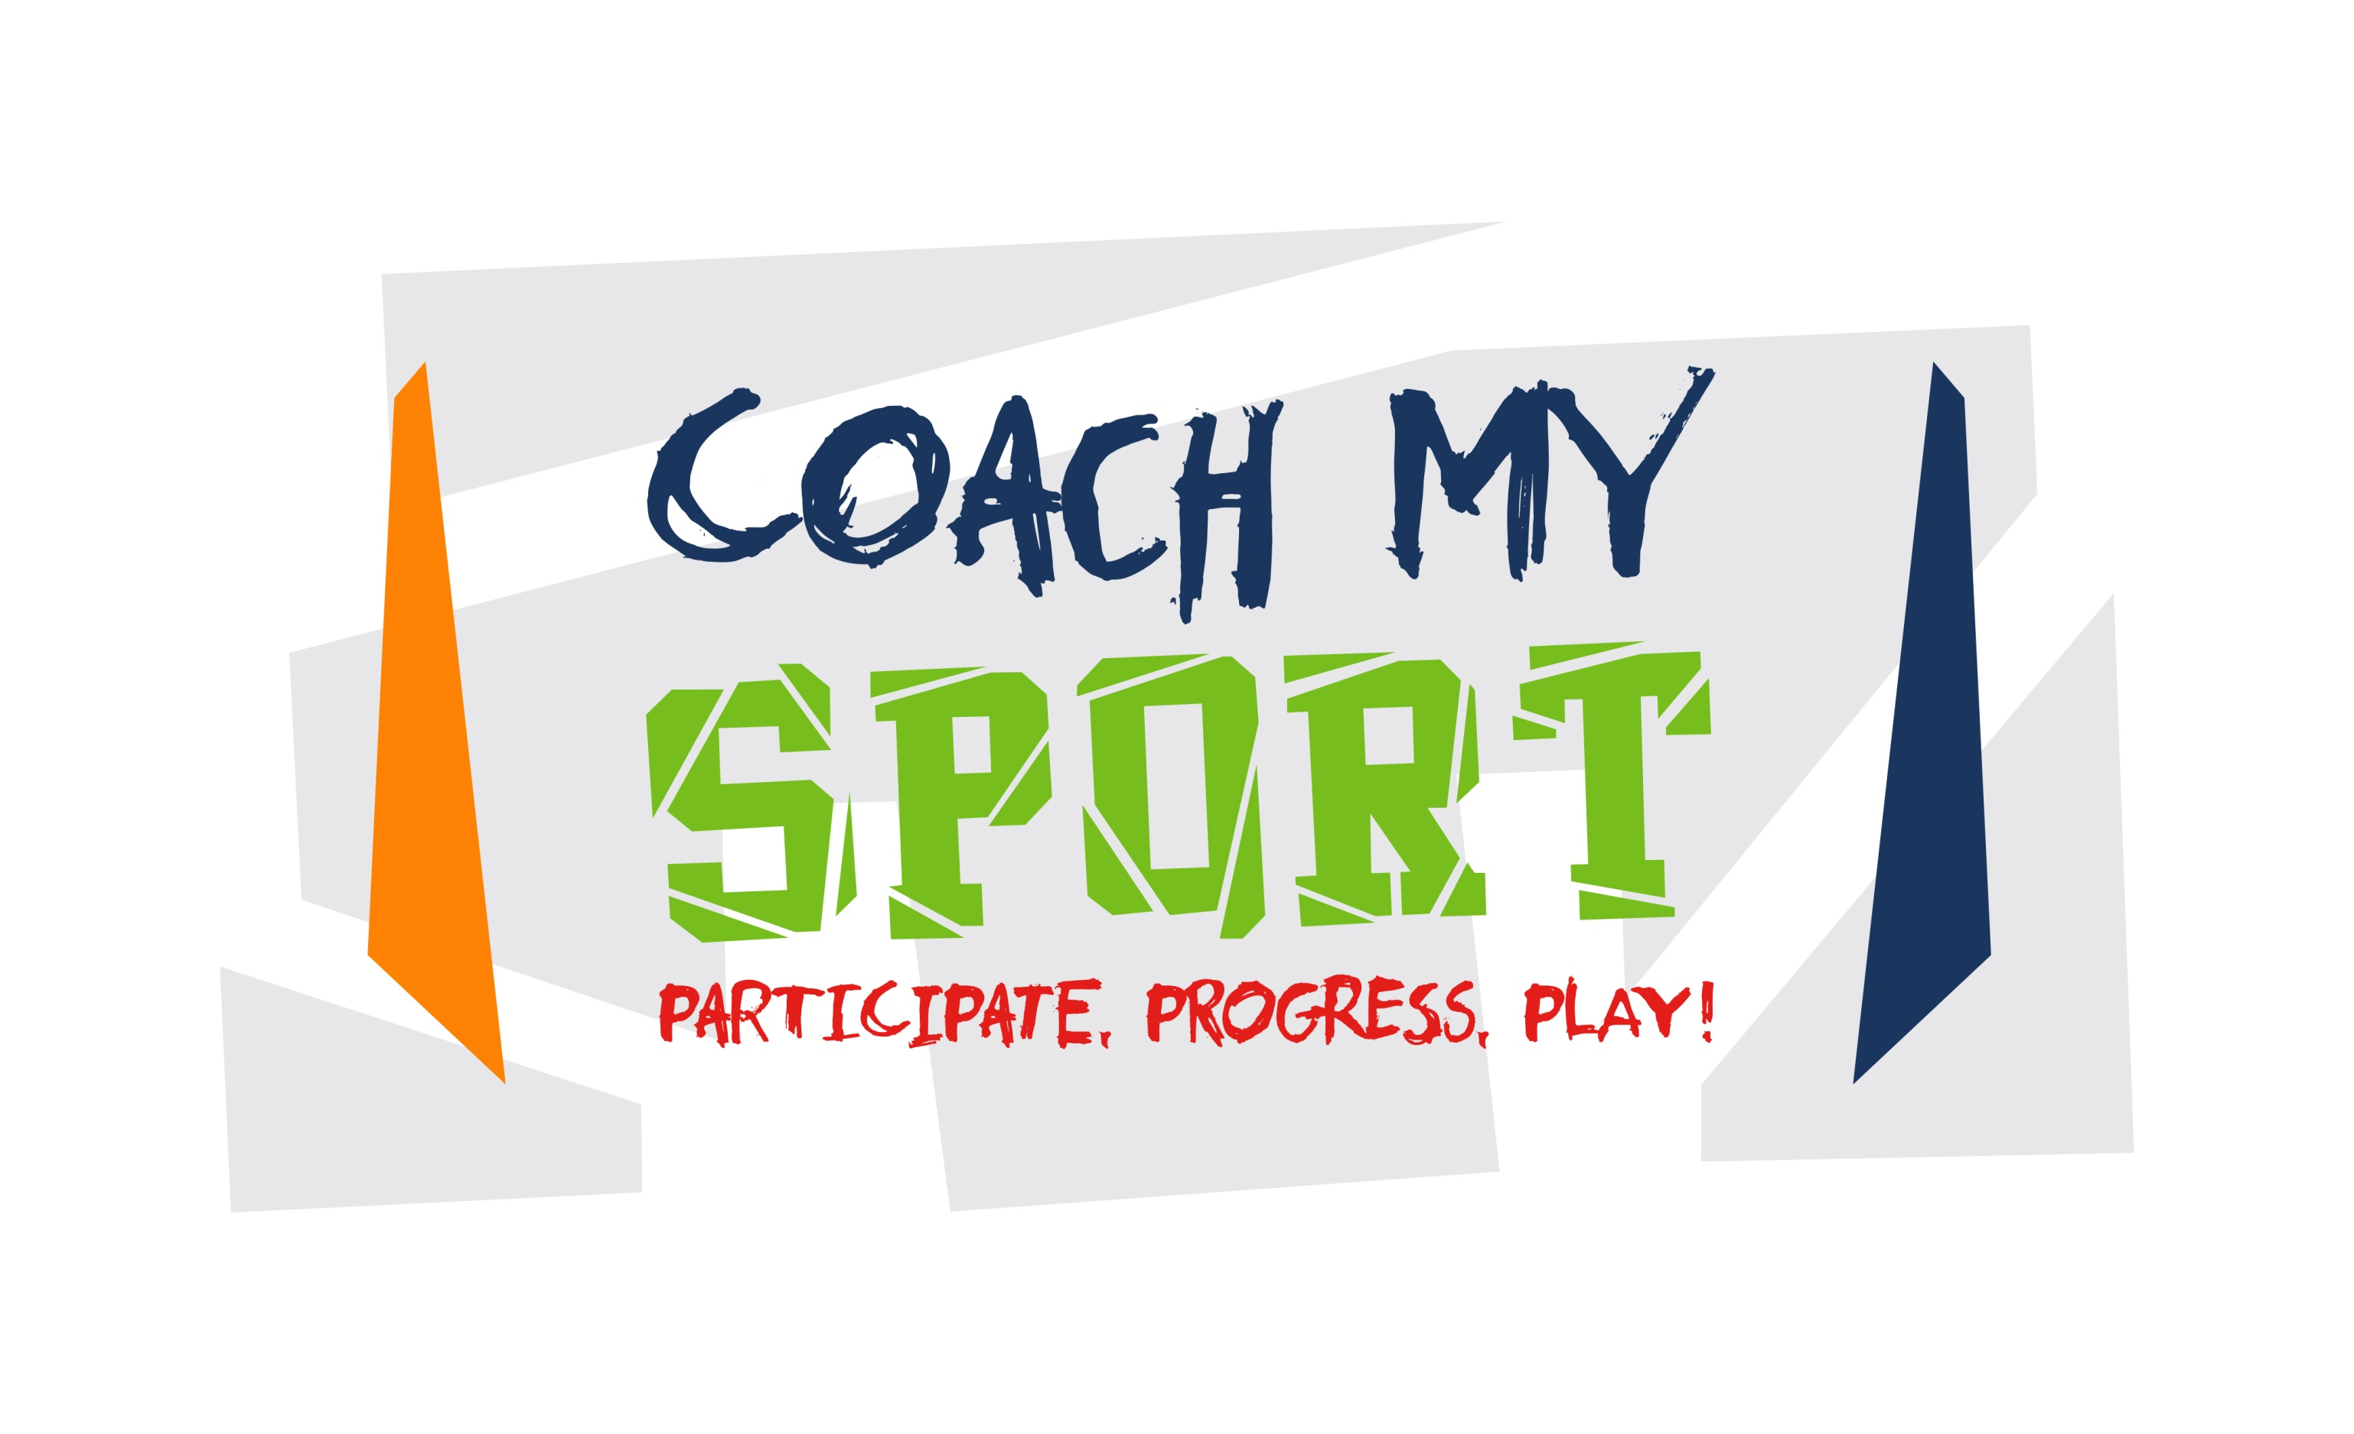

Please complete your details below. You will receive an email confirming your booking. Please note booking form and payment are required before your party can be confirmed.

For more information contact Tony on 07590 900101 or by email: coachmysport@gmail.com

* Required

Child's Name and Surname*
If more than 1 child, please include all names

Child 1: ____________________

Child 2: ____________________

Child's Date of Birth *

Child 1: ____________________

Child 2: ____________________

Parent's Name and Surname *

__________________________________________

Home Address and Post Code *

___________________________________________

___________________________________________

___________________________________________

___________________________________________

Telephone - Home * Telephone - Mobile *

__________________________ _____________________________

Email Address *

____________________________________________

Date and Time of Party *

____________________________________________

Duration of Party * (please circle)
1 hour (£55)

Venue for Party *

_____________________________________________

Anticipated number of Children Attending *
Final numbers need to be confirmed two days prior to the party.
_____________________________________________

How will you be paying? *
BACS: Account number: 16551968 Sort Code:80-22-60 - Please use your child's name and surname as reference. Cheque: Payable to Coach My Sport and sent to 12C Leny Road Callander FK17 8BA

BACS
Cheque

Total Amount *
1 hour (£80) and 1.5 hours (£95)

Please read the terms and conditions. *
Our cost does not include the cost of hall hire, party food or drinks.

Full payment is required in advance with the booking form.
No bookings can be confirmed until a booking form has been received with full payment:
Payment details as above. A full refund will be given if written cancellation is received within two weeks prior to the party date, if not we are unable to provide a refund.
There is no minimum number of children but the maximum number is 25 and this would be dependant on the size of the hall.
Party duration includes time for party food, drinks and cake.
Although we run all the classes in a safe and secure environment Coach My Sport cannot be responsible for any accidents.
The host parents need to make sure that they have spoken to all parents about taking photographs and videos plus have contact details of parents in case of emergencies.
Please let parents know it’s a sports themed party so the children need to come dressed appropriately.

I agree to the terms and conditions: Yes/No * delete as appropriate

Signed: _______________________________ Date: ____________________

